Assignment 2

Nicholas Colonna

2/11/2018

# Problem 2

#(a) Read the input file into a variable and print its first lines of data using the command head.  
micron <- read.csv('MU.csv', header=TRUE)  
micron$Date <- as.Date(micron$Date, "%m/%d/%y")  
head(micron)

## Date Adj.Close  
## 1 2017-01-03 22.55  
## 2 2017-01-04 22.36  
## 3 2017-01-05 22.11  
## 4 2017-01-06 22.04  
## 5 2017-01-09 22.34  
## 6 2017-01-10 22.48

#(b) Plot the daily close prices  
plot(micron$Date, micron$Adj.Close, main='MU Daily Close Prices 2017', xlab='Date', ylab='Adjusted Close', pch=20)

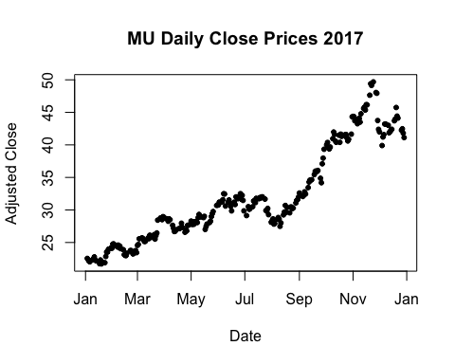

#(c) Compute the corresponding series of log-returns. Make another plot and report the summary statistics using the command summary.  
micron["Returns"] <- NA  
i <- 1  
while(i <= length(micron$Adj.Close)){  
 if(i==1){  
 micron$Returns[i] <- NA  
 }else{  
 micron$Returns[i] <- log(micron$Adj.Close[i])-log(micron$Adj.Close[i-1])  
 }  
 i <- i+1  
}

plot(micron$Date, micron$Returns, main='MU Daily Log Returns 2017', xlab='Date', ylab='Return', pch=20)

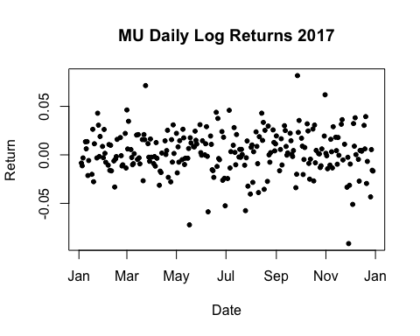

summary(micron$Returns)

## Min. 1st Qu. Median Mean 3rd Qu. Max. NA's   
## -0.091480 -0.009610 0.001947 0.002403 0.016030 0.081710 1

#(d) Do a box plot of the log-returns and verify if there are any outliers.  
boxplot(micron$Returns, main='MU Daily Log Returns 2017', ylab='Returns', pch=20)

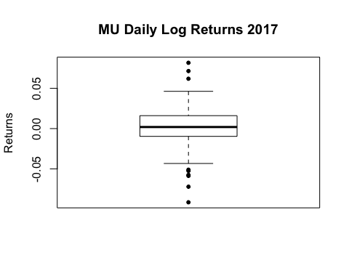

# Since there are a few points outside of the plot, it means that we have outliers in the returns in both the positive and negative direction

#(e) Do a normal qqplot with the log-returns series and comment your resuts.  
qqnorm(micron$Returns)

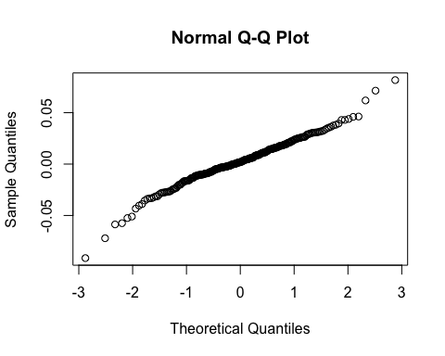

# Since the data points fall along a straight, ascending line on the normal qqplot, with a majority of the points in the interval [-1,1], it would be a safe assumption to say the log-returns of Micron are normally distributed